40
Asian Cultural Documentation Center
(Centers and Academies)
 |  |  | Logo | 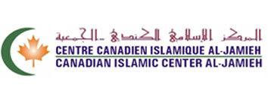
Name |  | Canadian Islamic Center Al-Jamieh
Head |  | ----------------
Type |  | Non-Governmental
Year of Establishment |  | ----------------
Publications | -----------------------
Activities | 1 – Holding daily prayers (Fridays and the two Eids) in the mosque which accommodates one thousand worshipers  2- Provides lessons to learn the Koran, religious worship, fikh and Sunna after al Maghreb prayers on Saturday, Sunday, Monday and Tuesday of every week  3- Teaching worship, fikh and Sunna for the women on Wednesday of each week from 11:00 am to 1:00pm  4- Saturday school for children from the age of 5 years to 16 years, teaching Arabic and Islamic religion  5- Institute of Islamic and Arabic Studies for teaching fikh, worship and memorizing the Koran and the stories of prophets and the Arabic language on Sunday of each week from 11:00 am to 1:00 pm  6- Holding collective breakfast on the first Sunday of every month for the Muslim community  7- There is an Islamic Library equipped with a selection of Islamic books on explaining (tafsir) the Koran, worship, fikh and sunna  8- There is a hall equipped with computer and internet available to all the community members.  9- In the Center, there is an equipped cafeteria to allow students to read and to host families  10- There is a sports hall to serve youth and to practice physical activities
Main disciplines | -----------------------
Website | http://www.cical-jamieh.com
E-mail | info@cical-jamieh.com
Fax | (514) 624-0833
Tel | (514) 624-5833
Address | Canadian Islamic Center ( Al-Jamieh ) 241 Anselme Lavigne D.D.O. Qc Canada H9A 3H6

