16
Asian Cultural Documentation Center
(Centers and Academies)
 |  |  | Logo | 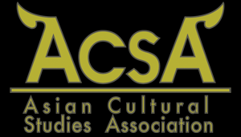
Name
Head |  | Dr Stephen Conlon
Type |  | ----------------------
Year of Establishment |  | ----------------------
Publications | Asian Journal of Literature, Culture and Society
Activities | ------------------------
Main disciplines | ASIAN CULTURAL STUDIES ASSOCIATION (ACSA) is an international academic society under the patronage of Assumption University of Thailand, devoted to the study of Asian arts, cultures and societies. The society aims to promote the work of international scholars on Asia-related aspects in literature, language, literary criticism, film & media, theatre & performing arts, art & design, architecture, new media, cultures & societies, gender, race & ethnicity, popular culture, martial arts, religion, philosophy, ideology, semiotics, critical theory and any other forms of cultural expression, as well as the work of Asian scholars in the broadly understood area of arts and humanities.
Website | http://www.gse.au.edu/index.php?option=com_content&view=article&id=94&Itemid=40
E-mail | gse@au.edu
Fax | +66 (0) 2318 7159
Tel | +66 (0) 2300 4543 - 62 Ext. 1348
Address | Graduate School of English, Assumption University, Ramkhamhaeng Rd. Soi 24, Hua Mak, 10240 Bangkok, THAILAND

