1
Asian Cultural Documentation Center
(Centers and Academies)
 |  |  | Logo | 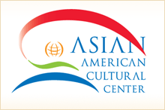
Name |  | Asian American Cultural Center
Head |  | http://asacc.uconn.edu/
Type |  | --------------------
Year of Establishment |  | 1993
Publications | -----------------------
Activities | ----------------------
Main disciplines | The Asian American Cultural Center (AsACC) provides resources to enhance the University's diversity commitment through its recruitment and retention efforts, teaching, service, and outreach to the Asian American community on campus and beyond. Central to all its programming, the AsACC assists students in exploring and defining their cultural identity in multicultural America. The AsACC provides a supportive environment for students, faculty, and staff that encourages academic excellence, personal development, community engagement, and professional leadership.
Website | http://asacc.uconn.edu/
E-mail | asacc@uconn.edu
Fax | (860)486-1606
Tel | (860)486-0830
Address | University of Connecticut  Asian American Cultural Center  Student Union Building — Rooms 424–436  2110 Hillside Rd. U-3186  Storrs, CT 06269-3186

