Asian Cultural Documentation Center
(Researchers)

 |  | Photo | 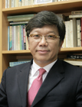
Name | Woo Young Lee
Born
Nationality
Field
Education
Publications
Experience | Prof. of University of North Korean Studies
E-mail | wylee@kyungnam.ac.kr
Fax
Phone | 02-3700-0727
Address

