Asian Cultural Documentation Center
(Researchers)

 |  | Photo | 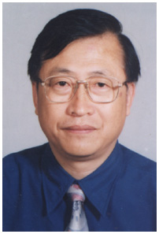
Name | Wang Shaopu
Born | 1952
Nationality | China
Field | History
Education | PhD Fudan University in 2007
Publications | Divergent Trends in the Oriental Cultural Circle;  The Economic Cooperation in the Asia-Pacific Region (co-author);  A Study on the National Defense of the Post-war Japan (co-author)  China’s East Asia Strategy and the Structure of the Asia-Pacific Regional Relations (co-author).
Experience | Director with the Institute for Asia-Pacific Studies  Shanghai Academy of Social Sciences  Vice President of the Shanghai Society for Japan Studies
E-mail
Fax | 86-21-62831110
Phone | 86-21-62811607
Address

