Asian Cultural Documentation Center
(Researchers)

 |  | Photo | 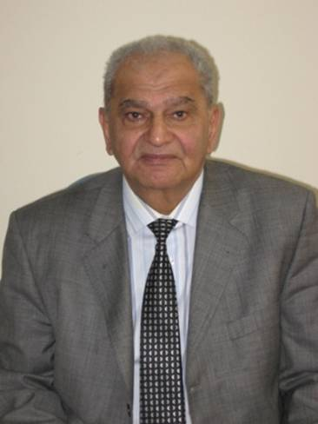
Name | VASIMMAMEDALIYEV
Born | 1942 on August 27 in Baku
Nationality | Baku
Field
Education | In1959-1964 got high education at the faculty of Oriental languages of BSU  In1965-1968 passed the whole doctorate course under the leadership of  a famous academician in oriental languages G.V.Tseriteliin Tbilisi.  In 1968 defended the dissertation in the State University of Tbilision the  theme “ The comparative –topologic analysesof the category of time of verbs in the  Modern literary Arabic and Azeri languages as well in Iraqi dialect “  In 1974 defended the dissertation for Doctor degree in theState University  of Tbilisi on theme “ The category of time, person and mood of verb in  the Modern literary Arabic language”  Professor since 1978  The member of Academy of Iraq since 1989, İnternational Academy of Figh  in Organization of Islamic Conference since 1994, Academy of Koran sciences  since 1995, Academy of the Arabic language of Egypt since 2003  In 1992 got the name “ Honoured Scientist of Azerbaijan  In 2001 was chosen the member of ANAS  In 2002 was awarded with “Order ofGlory”  In 2003 got the name “Honoured Scientist of the Republic of Dagestan”  In 2007 was chosen the academician of NASA
Publications
Experience
E-mail
Fax
Phone
Address

