Asian Cultural Documentation Center
(Researchers)

 |  | Photo | 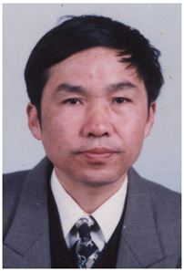
Name | Sun Keqin
Born
Nationality
Field
Education
Publications | Book:  1. Social Policy: Lessons from Europe and Challenges Facing China (2005, coordinated, edited by Zhou Jianming), Shanghai Academy of Social Sciences Press.  2. Law Basic for Social Work (2003, coordinated), Shanghai Academy of Social Sciences Press.  Paper:  1. Reform of Social Insurance for Old-Age in China during Social Transformation.  2. Reform of Insurance for Old-Age and Social Harmonic Development in Shanghai;  3. On the Economic Activity of Middle Income Groups in Shanghai.  4. Studies on the Improvement of the System of “Minimum Cost of Living in Shanghai Towns  5. Studies on the Linking-Up of Philanthropy and Governmental Social Assistance.  6. On the Issues of Employment in Shanghai during Social Transformation.  7. Studies on the Social Stability and Social Development in Shanghai.
Experience | Master of Economics;  1982.2-1992.12 Worked in the Science & Research Division,  Shanghai Academy of Social Sciences and assumed the Deputy-director of the Division in May, 1988.  1993.1-2001.6 President of Shanghai Academy of Social  Sciences Press;  2001.7- present Deputy Director of Institute of Sociology, Shanghai Academy of Social Sciences Press; editor-in-chief of the journal of Sociology; Professor.
E-mail
Fax
Phone
Address

