Asian Cultural Documentation Center
(Researchers)

 |  | Photo | 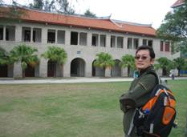
Name | Sun Jingting
Born
Nationality
Field
Education
Publications | ·Transformation and Integration: Political Parties in Central and Eastern European Countries, Chinese Literature & History Press, Jan. 2006  ·German Left Party: Dilemma and Choice, Journal of Contemporary World & Socialism, March 2007  ·Positioning and Track of Development of Right Wing Political Parties In Central and Eastern European Countries, Journal of Social Sciences, Dec. 2005
Experience
E-mail | sjt@sass.org.cn
Fax
Phone | +86 21 5306
Address

