Asian Cultural Documentation Center
(Researchers)

 |  | Photo | 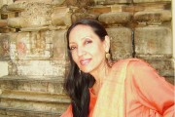
Name | Prof. Dr. Smita Twari Jassal
Born
Nationality
Field
Education
Publications
Experience | Agrarian change, caste and class, gender and development, cultural studies, oral culture and folk songs, partition, modes of comparison.
E-mail
Fax
Phone | +90 312 210 3108
Address

