Asian Cultural Documentation Center
(Researchers)

 |  | Photo | 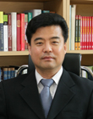
Name | Phillip H. Park
Born
Nationality
Field
Education
Publications
Experience | Director of International Affairs, Institute for Far Eastern Studies
E-mail | parkphillip@kyungnam.ac.kr
Fax
Phone | 02-3700-0756
Address

