Asian Cultural Documentation Center
(Researchers)

 |  | Photo | 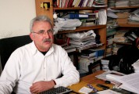
Name | Prof. Dr. Mehmet Ecevit
Born
Nationality
Field
Education
Publications
Experience | Social thought, feminism, social science methodology, sociology of family, rural sociology
E-mail | ecevitm@metu.edu.tr
Fax
Phone | +90 312 210 5993
Address

