Asian Cultural Documentation Center
(Researchers)

 |  | Photo | 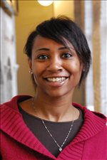
Name | Mareah Peoples
Born
Nationality
Field
Education | 2009 The American University in Cairo: Master of Arts in Middle East Studies (Cairo, Egypt)  2003 Indiana University of Pennsylvania: Bachelor of Arts in Anthropology (Indiana, Pennsylvania)  1999 Central Dauphin East High School: College Prep (Harrisburg, Pennsylvania)  1993 Dar-Al Tarbia: Humanities (Jeddah, Saudi Arabia)
Publications
Experience | 2011---> Peace Research Institute Oslo(PRIO) Researcher on the Middle East  2009-2010 Peace Research Institute Oslo (PRIO): Internship  2008-2009 American City College (Cairo, Egypt): High school History Teacher  2006-2008 Private Tutor(Cairo, Egypt): Education training  2005-2005 The American University in Cairo: Teacher Assistan  2002-2003 Miami University Law School Office of Admissions and Recruitment: Administrative Assistant
E-mail | marpeo@prio.no
Fax
Phone | (+47) 47 35 46 08
Address

