Asian Cultural Documentation Center
(Researchers)

 |  | Photo | 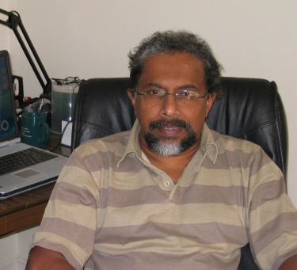
Name | Professor M W Amarasiri de Silva
Born
Nationality
Field
Education
Publications | · “Ethnicity, Politics and Inequality: The Post-Tsunami Humanitarian Aid Delivery Process in Ampara District, Sri Lanka", Disasters: The Journal of Disaster Studies, Policy and Management. Vol. 33, Number 2, April 2009. DOI: 10.1111/j.1467-7717.2008.01073.x  · Care seeking in Sri Lanka: One possible explanation for the low Childhood Mortality (Social Science and Medicine. Vol. 53/10, pp 1363-1372) doi:10.1016/S0277-9536(00)00425-1  · Child rights Violations as seen by children The Island Newspaper, Feature article 28th March 2007  · Endangered Democracy: Tsunami Aid distribution in Ampara district. UNDP, Regional Centre in Bangkok 2007 June  · Preserve Traditional Fishing Sector after tsunami Newspaper article. The Island, Aug-12-05  · Is Malnutrition a biomedical problem? The Island Newspaper, July 20th 2006  · Relocation of Internally Displaced Persons (IDPs) into the host communities in Anuradhapura District, Sri Lanka: Socio political and planning implications. April 2006  · Maternal Mortality in the Central Province of Sri Lanka: Sociological analysis of lay perspectives. Peradeniya University Research Sessions (PURSE), 2003.  · Food Gifts, Kinship and Weight Gain during Pregnancy in Rural Sri Lanka. The Sri Lanka Journal of the Humanities, Volumes XXVII & XXVIII (Numbers 1 & 2) 2001-2002 (co-author)  · Evaluation of the Nutrition Supplement Programme (biscuit Programme) in the four districts of Ratnapura, Monaragala, Badulla Hambantota, 2000 (co-author)  · Community-based Sexual Risk Prevention Program for Sri Lanka: Influencing Sexual Risk Decision-Making. International Quarterly of Community Health Education, 18(1) 139-155, 1998-99(co-author).  · The Social and Political Context of Community participation in Primary Health in a Rural Sri Lankan District.  · Situational Analysis of Gender, Sexuality and Reproductive Health in Sri Lanka, 1995 (co-author).  · One year after Tsunami: Are we ready for reconstruction? The Island Newspaper 26th December 2005  · Technological change in a coastal fishing community in Southern Sri Lanka, Marga Journal, 1976  · Report on the Tsunami affect in Ampara District. August 2005  · Socio-political Implications of conflict related Internal Displacement in Sri Lanka. Paper presented at the Forced Migration conference in Oxford, UK, July 2005  · Tsunami: Do we have the right data? Newspaper article published in The Island, on 17th January 2005  · Children Affected by Armed Conflict in the Eastern Province. CEPA, Colombo November 2005(co-author)  · Relations between Transnational and Local Non Governmental Organisations in War-affected Areas of Sri Lanka. American Anthropological Association meeting in Atlanta, USA 2004.  · Transition from War to Peace: A Sociological study to facilitate the social reconstruction process in war-torn areas of North and East of Sri Lanka. 9th International Conference on Sri Lankan Studies, November 2003  · Reproductive Health among Internally Displaced persons of Sri Lanka. The Marie Stopes International, London, August 2000. Pp 135 + Appendices.  · Some Socio-political Implications of Internal Displacement of Populations (IDPs) in Sri Lanka. Paper presented at the 7th Sri Lanka Studies Conference, Canberra, Australia, 1999.  · Structural Change in a Coastal Fishing Community in Southern Sri Lanka. Marga Journal - Vol. 4, No: 2. 1979
Experience
E-mail | mwades@sltnet.lk, mwadesilva@gmail.com
Fax | +94-81-2214230
Phone | +94-71-8450630 (office) /+94-77-3515526 (home)
Address

