Asian Cultural Documentation Center
(Researchers)

 |  | Photo | 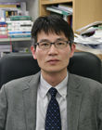
Name | Kab-Woo Koo
Born
Nationality
Field
Education
Publications
Experience | Director of Planning , Institute for Far Eastern Studies
E-mail | kwkoo@kyungnam.ac.kr
Fax
Phone | 02-3700-0735
Address

