Asian Cultural Documentation Center
(Researchers)

 |  | Photo | 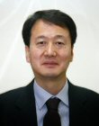
Name | Jong Dae Shin
Born
Nationality
Field
Education
Publications
Experience | Prof. of University of North Korean Studies
E-mail | shinjd@kyungnam.ac.kr
Fax
Phone | 02-3700-0728
Address

