Asian Cultural Documentation Center
(Researchers)

 |  | Photo | 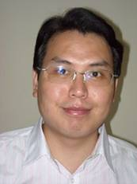
Name | Jiao Shixin
Born
Nationality | China
Field | International Institutions, Sino-U.S relations, the Construction of International Institution on East Asia, and Canadian Politics and Diplomacy.
Education | PhD Fudan University in 2007
Publications | The Balance of Interest——the Role of U.S Participating in International Institutions, World Knowledge Press, 2008.  “From closure to engagement: Obama administration’s “New Deal” toward the North Korea”, Contemporary International Relations, No 3, 2010  “The end of post-Cold War era and Its Implications toward China,” World Economy and Politics  "Financial Crisis and Plural Globalization Order", Social Science, No 9, 2009.
Experience | Director of APEC Research Center, Shanghai Academy of Social Sciences (SASS).  Master, International Politics of Fudan University in Shanghai in 1982  Institute of Asia-Pacific Studies
E-mail | jiaoshixin@sass.org.cn
Fax
Phone | +86 21-53060606-02454
Address

