Asian Cultural Documentation Center
(Researchers)

 |  | Photo | 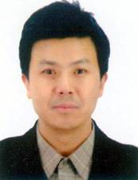
Name | Hu Zhiyong
Born
Nationality
Field
Education
Publications
Experience
E-mail | huzhiyong@sass.org.cn
Fax
Phone | +86 21 28592911
Address

