Asian Cultural Documentation Center
(Researchers)

 |  | Photo | 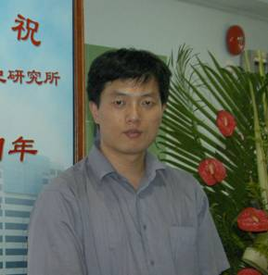
Name | Gao Jun
Born
Nationality
Field
Education
Publications | BOOK/ MONOGRAPHY AUTHORED  Critical biography of Mu Ouchu (Shanghai Renmin press Oct. 2007)  CHAPTERS IN BOOKS  1．“Political party” “Medical system” “Marriage”, in The introduction of western institutional civilization and its influence on Chinese (Changchun Publishing ,Nov. 2004)  2．Chapter 1, chapter 6, in The history of St. John University (Shanghai Renmin press, Jun. 2007)  3．Chapter 2, chapter 6, chapter12, in The Shanghai: Chronicle of a Metropolitan (Shanghai shudian press 2007)  BOOK REVIEW  Criticize on THE OUTSIDERS: The Western Experience in India and China written by Prof. Rhoads Murphey , SHANGHAI STUDIES IN THE WORLD ,Aug.2004  SELECTED ARTICLES IN JOURNAL  1. The May Fourth Movement and Gongjinshe--A political group organized by young intellectuals. Journal of Yan’an University ,No.12, 1999.  2. The Political Influence of Merchant Group in the Modern China’s History ,HISTORICAL REVIEW, No.6, 2004  This article was awarded the National first-rank scientific dissertation for young scholars  3. Analysis of the Development and Influence of Sun Yat-sen’s Theory of Party Politics,The Monograph on THE INTERNATIONAL SYPOSIUM ON SUN YAT-SEN AND MODERN  The Analysis of the Political Elites of Hunan Province  HISTORICAL REVIEW, No.5, 2005  3.The Preliminary Exploration on the Party Politics in the ROC Period, JOURNAL OF NANKING NORMAL UNIVERSITY, No.1, 2005.
Experience | Gao Jun 高俊  Male 男  Assistant Researcher 助理研究员  Brief introduction  B.A. Northwest University 西北大学学士  M.A. East China Normal University 华东师范大学硕士  Ph.D. Fudan University 复旦大学博士  PD.RF. National University of Singapore 新加坡国立大学博士后研究员  Research interests  History of modern China 中国近代史  Urban History of Shanghai 上海城市史  Current research  Life history of modern Shanghai 上海城市生活史
E-mail
Fax
Phone
Address

