Asian Cultural Documentation Center
(Researchers)

 |  | Photo | 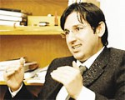
Name | Erasmus Mundus Coordinator
Born
Nationality
Field
Education
Publications
Experience | Alevis, migration, political anthropology, voluntary organizations, anthropology of the European Union, Middle East (Turkey & Iran)
E-mail | aerdemir@metu.edu.tr
Fax
Phone | +90 312 210 3122
Address

