Asian Cultural Documentation Center
(Researchers)

 |  | Photo | 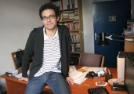
Name | Dr. Barış Mücen
Born
Nationality
Field
Education
Publications
Experience | Historical sociology, political sociology, cultural sociology, post-colonial studies, social theory
E-mail | mucen@metu.edu.tr
Fax
Phone | +90 312 210 5998
Address

