Asian Cultural Documentation Center
(Researchers)

 |  | Photo | 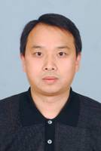
Name | Cao Yongxin
Born
Nationality
Field
Education
Publications | ·Theory of International Relations of Maxism ,(2009)  ·Peace and Ideologies,(2005).  ·Advanced Culture in Modernization,(2005).  ·Culture Mission of the Party,(2011).
Experience
E-mail | cyx@sass.org.cn
Fax
Phone | +86 21 64274736
Address

