Asian Cultural Documentation Center
(Researchers)

 |  | Photo | 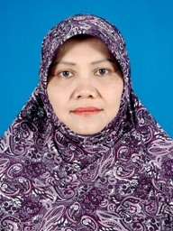
Name | Dr BUDIWANTI Erni
Born
Nationality
Field
Education | Ph.D (Anthropology) Monash University, Australia  M.A. (Anthropology) Monash University, Australia  Honours (Sociology) Airlangga University, Indonesia
Publications | Authored Book and Monograph  1995  The Crescent Behind the Thousand Holy Temples: An Ethnographic Study of the Minority Muslims of Pegayaman, North Bali. Yogyakarta: Gadjahmada University Press, 1995.  Edited Book  2004  A Study on the Inter-Ethnic Conflicts in Sambas, Poso, and Ambon. Research Center of Human Rights, Ministry of Justice.  2003  Multiculturalism, separatism, and Nation-state Formation in Philippines. Jakarta: Center for Regional Resources, Indonesian Institute of Sciences (PSDR-LIPI).
Experience | 2008 - current  Researcher at the Research Center for Regional Resources, Indonesian Institute of Sciences (PSDR-LIPI)  2004 - 2008  Lecturer, Faculty of Education and Teacher Training, Mataram University of NTB province, Indonesia  2004  Visiting Researcher, Institute of Liberal Arts, Walailak University, Thailand  2001 - 2004  Head of Asia Pacific Study at the Research Center for Regioal Resources, Indonesian Institute of Sciences (PSDR-LIPI)  1986 - 2001  Researcher at the Research Center for Political Studies, Indonesian Institute of Sciences (P2P-LIPI).
E-mail
Fax
Phone
Address

