Asian Cultural Documentation Center
(Researchers)

 |  | Photo | 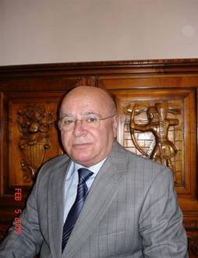
Name | Azizov Elkhan
Born | Born on October 25, 1946 in Agdash town
Nationality | Azerbaijan
Field
Education | - 1989 – Associate Professor, Chair of Arabic Philology, Faculty of Oriental Studies, BSU  - 1974 – Candidate of Philological Science (PhD): “Reflection of huramid’s movement in Arabic poetry of IX century”  - 1970 – 1973, postgraduate student, Institute of Oriental Studies, Academy of Sciences  - 1964 – 1970, student, faculty of Oriental Studies, BSU
Publications | - 2007, Curriculum on “History and methodology of Arabic literature” (for graduates)  - 2007, Curriculum on “Source studies” (for graduates)  - 2007, Curriculum on “Source studies” (for graduates)  - 2003, Book of Ibn Khisham “as-Sira an-Nabaviyya” as a source of literature  - 2002, Egyptian literature in Azerbaijan (in Arabic, Cairo)  BOOKS  - 1972, Telephone number (stories for children)  - 1979, protection of the fish wealth and foundation of fishery in Kuwait (translation into Arabic, Kuwait)  - 1980 Sharks in Persian Gulf (translation into Arabic, Kuwait)  - 2002, Life moments (about academician Mamedaliyev)  - 2004, Reflection of Khuramid’s movement in Arabic poetry of IX century  - 2007, Bad for good (fables and humoristic stories)
Experience | INTERNATIONAL SEMINARS, SIMPOSIUMS AND CONFERENCES  - 2008, Tehran, seminar on international exhibition of books  - 2007, South Korean Republic, preparation of agreements among BSU, PaiChai University and Sunlin University  - 2004, Saint Petersburg, International Conference on Bologna Process  - 2002, Cairo, workshop devoted to relations between Egypt and Azerbaijan  - 1992, Tehran, International symposium, devoted to the anniversary of Iranian Islamic revolution  - 1991, Izmir, signing of agreement between University of Aegean and BSU
E-mail | Elkhan_Azizov@mail.ru
Fax
Phone | +(994)12 438 14 52
Address

