Asian Cultural Documentation Center
(Researchers)

 |  | Photo | 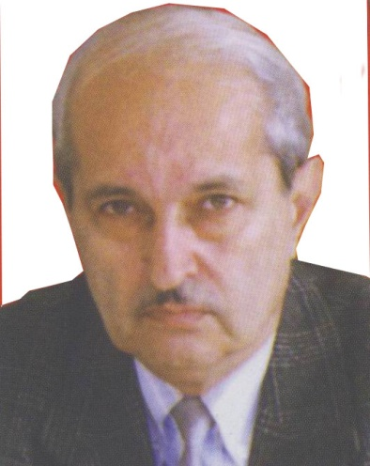
Name | Alizade Yalchin Mustafa oglu
Born | Was born on january 17, 1940 in Ganja
Nationality | Azerbaijan
Field
Education | - 1974 - c.p.s., "The formation and development of radio journalism in Azerbaijan"  - 1999-2008 - dean at the faculty of journalism, BSU  - 1982-1999 - head of chair at the chair of TV and radio journalism, BSU  - 1979-1989 - chairman, The teachers Trade Union Organization of BSU  - 1974-1981 - lecturer, Senior lecturer, Associate professor at the chair of theory and practise of journalism, BSU  - 1971-1974 - post-graduate at the faculty of journalism, BSU  - 1962-1971 - worked in the State TV and radio broadcasting Committee of Soviet of Ministers of Azerbaijan SSR  - Subjects: The basis of tv and radio jurnalism, Theory and practice litheral editing  - The author of 70 scientific article and 4 book
Publications | LIST OF SELECTED PUBLICATIONS  - 2008 - 4-volume- book „Heydar Aliev and media", the new approach to journalism  - 2008- The life school of genarations  - 2007 - The life devoted to journalism  - 2006 - The bright life  - 2005 - The word said in time and in its place  - 2005 - The success two wings  BOOKS  - 2006 - The broadcasting of Azerbaijan - history and modernazation (co-author with prof. G. Maharramli)  - 1991 - The basis of radiojurnalism  - 1972 - The lights underground  - 1961 - The lighthouse of Mughan
Experience | - 1999-2008 - dean at the faculty of journalism, BSU  - 1982-1999 - head of chair at the chair of TV and radio journalism, BSU  - 1979-1989 - chairman, The teachers Trade Union Organization of BSU  - 1974-1981 - lecturer, Senior lecturer, Associate professor at the chair of theory and practise of journalism, BSU  - 1971-1974 - post-graduate at the faculty of journalism, BSU  - 1962-1971 - worked in the State TV and radio broadcasting Committee of Soviet of Ministers of Azerbaijan SSR  - Subjects: The basis of tv and radio jurnalism, Theory and practice litheral editing  - The author of 70 scientific article and 4 book
E-mail | alizade_y@mail.ru
Fax
Phone | +(994) 12 438 42 08
Address

