Asian Cultural Documentation Center
(Researchers)

 |  | Photo | 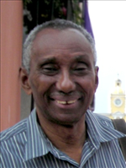
Name | Alain Gilles
Born
Nationality
Field
Education
Publications | Hauge, Wenche Iren; Rachelle Doucet & Alain Gilles, 2008. 'Conflict Prevention in a DDR Context in Haiti'.
Experience
E-mail | ag952@columbia.edu
Fax
Phone | +509 401-6212
Address

