Asian Cultural Documentation Center
(Researchers)

 |  | Photo | 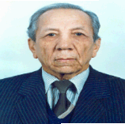
Name | Akilov Komil Akilovich
Born | 05.02.1928
Nationality
Field
Education | History faculty of Samarkand State University 1949 г.  Degree  Doctor of Sciences in 1987, The Institute of History AS Uzbekistan.  Scientific interests  The history of Soviet Union, contemporary social-economic issues
Publications | Автор более 100 научных работ
Experience
E-mail | tarih@uzsci.net
Fax
Phone
Address

